The Stem

Note for adults: All these lessons are told as stories or conversations. Therefore, the adult’s job is to prepare by reading the stories to themselves and extracting the main points. Then the adult is free to tell the story in their own voice, ensuring the main points are covered.

Botany Impressionistic Charts:
Hand-drawn option: purchase here
Realistic photographs (from Montessori for Everyone) : purchase here
Reimagined charts from Rhyme & Reason Academy: here

Note: the hand-drawn charts are the traditional option, since they inspire children to draw their own. But some families prefer realistic photographs.

MATERIALS:
Charts:
- #14 - the water pump
- #15 - the clinging vine
- #16 - twining and hooks (the second picture is the same plant [hops], enlarged)
- A geranium (or similar plant with soft green stem)

- Two celery stalks
- Two cups
- Water
- Red food dye

Experiment (done at least 24 hour BEFORE telling the story):
- Put one celery stalk in clear water and one celery stalk in red water.
- Tell the children: We’ll come back to observe it tomorrow and see what happened.
- The former will look fresh and green, while the latter will look pinkish.
- The leafier the stalk, the better the experiment works.

The story of the stem: Given as a conversation

If all plants grew close to the ground and remained on the ground, there would be the most incredible overcrowding and a lot of them would die in the great struggle for light. So what is it that carries the leaves up into the air towards the light so that the leaves can spread out as much as possible? The stem. It's the stem that brings the leaves up towards the light. The stem has the tendency to grow upwards. (Recall the "roots go down" experiment, in which the shoot goes up while the roots go down, if you already covered the topic of roots.)

If we look around us we can see all sorts of stems. For example: look at the geranium's stem. It is soft and green; we call it a herbaceous stem (note: herbaceous comes from the Latin herba, meaning "grass"). A plant with stems like that has a short life but if we look around out the window, we can see trees. Trees have an impressive stem that we call a trunk. The stem of a tree is much much thicker and it's made of wood. Therefore, we call it a woody stem. Plants with woody stems live much longer than a plant such as a geranium. Trees grow year after year after year, and some grow for thousands of years. Why might the woody stem play a role in allowing the tree to live a long time? Discuss. (note: It is remarkable that plants keep growing for as long as they are alive.)

The stem's job is to take the leaves to the sun. It has another job as well: to bring water up to the leaves. Think of the tree; think of the water traveling up the tree. After all, where does the water enter the plant? Through the roots. But then the water has to travel all the way up, right to the very top of the tree because it has to reach all of the leaves, even the very highest leaves. That means that the stem sometimes brings the water up to incredible heights. For the stem to be able to do that, they have pipes inside so that the water can travel up the stem.

Bring out the celery experiment.

Observations with the children:
What does it mean that we see red in the one in the colored water, all the way to the top leaves? The water has traveled up through the pipes in the stem all the way to the top end of the plant.

Let's look for evidence of the pipes. Take out the celery stalk from the colored water and show the little red dots at the base of the stem. Then, cut through the stem to show the pipes.

Stems always have pipes for carrying up the water. Trees are so clever: their special pipes are just inside the bark. The bark protects the pipes from heat, cold, and animals. (Note: It’s important to address this so children don’t damage the tree’s bark in their explorations.) Trees also make new pipes every year. How do we know? We can see the rings when we cut through the trunk. Show a bisection of a tree trunk if you have one. The rings tell us how old the tree is. The living pipes are always found around the outermost part of the stem of the tree. The pipes that are closer to the center of the stem were made and used when the tree was young and now they're dead. Have you ever seen a tree that's hollow? The tree that's hollow means that the center of the tree is gone but it's still a living tree; that's possible because the living pipes are not at the center. However, the old pipes that are dead still have a function that they can carry out: they act like a support and lend strength to the tree.

Now let's think about the living pipes. There are two kinds: food pipes that carry the food that the leaves have made and water pipes that are used for carrying the water up and up and up to the topmost leaves. The food pipes are right next to the bark and the water pipes are a little further in. The water pipes have a little extra protection: the bark and the food pipes serve as protection.

(pausing point)

Continuing with the story on a different day...

The Journey of the Water / How does the liquid rise in the plant? (Given as a conversation)

MATERIALS:
- Chart #14
- Paper towel
- Cup with water (and food dye if available)

PRESENTATION: The Journey of the Water

I wonder how the water gets up right to the top of the tree so that all the leaves have the water? How does the stem manage to carry water up so high, sometimes hundreds of feet high? After all, even the tallest tree has to ensure that even the smallest leaf all the way at the top also gets some water from the roots. It is said that Redwoods can be as tall as 350 ft.

The first part of water's journey begins when the cells of the root hairs take water in from the soil. We can imagine the water taken in by the first cell. The cell swells and passes the drop on to the next cell. Then that one swells and passes the drop to the next cell... Cell after cell after cell. This traffic of water is one-way only, like a one-way street. Once the water has entered, it cannot leave through the roots again. When the water moves through the root in this way, we call it root pressure because each little drop of water is being pressured - pushed - by the drop of water behind it. This pushing is enough to carry the water part of the way. But the pressure from the root is not strong enough for the water to be able to complete the journey all the way up to the leaves.

We already know that the leaves give off water. One cell calls to the other: "I'm thirsty". The call goes from neighbor to neighbor all the way to the root. The water is then pulled up. There's a pushing from the root and a pulling from the leaves.

Roll up a paper towel and stick it in the water (only the tip). The water will rise up the tissue.

We can think of this as pulling, as if the tissue is pulling the water into itself. The fact that water is being pulled up as well as pushed we also saw with our celery. Our celery has leaves but it has no roots! We can't see any! It's the leaves that pulled that water up. Can we pull water up? Yes, through a straw. We can think of the leaves doing just that. We can think of all of this happening in the tree and that's what we see on the chart. Show chart #14.
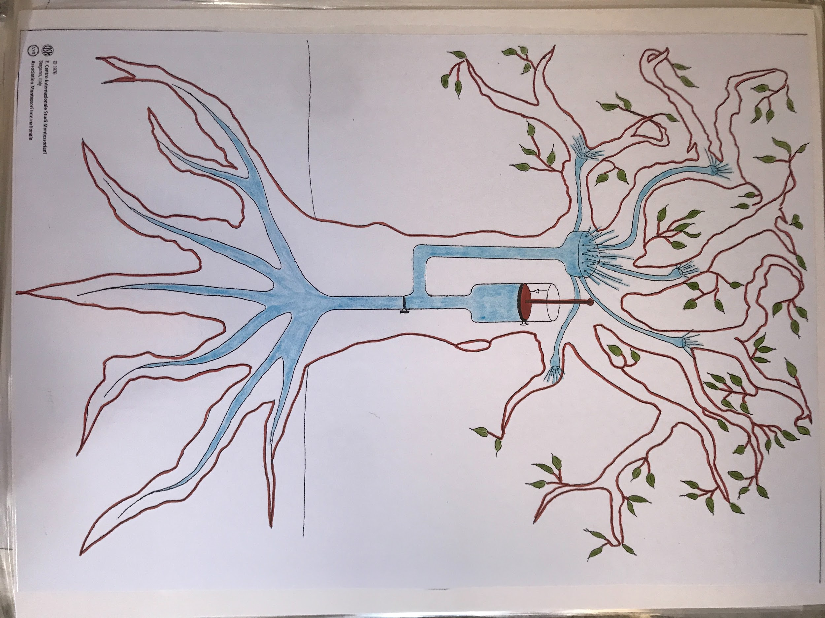
It's as if we can imagine a water pump in the tree. When we think of the whole stem, we can think of the water being pushed up from the roots and pulled by the leaves. This is how the water rises in the plant; it's how the water can reach the very top leaf.

Extensions:

Osmosis:
The older children can explore osmosis.
Experiments: https://sciencing.com/osmosis-science-activities-kids-6364184.html

osmosis: the process whereby substances can move from areas of low concentration to areas of high concentration of salts.

Varieties of stems:

MATERIALS:
- rhizome: ginger
- tuber: potato
- bulb (layers): onion
- corm (solid): crocus or gladiola

(Note: these can be ordered online or purchased at nurseries. Also, check with your local gardening groups to see if they have samples they can give you for free.)

PRESENTATION: Varieties of stems
Where do we usually find stems? Above the ground. These are called aerial stems. However, some stems have decided to live underground because that way they can also store food. If they are storing food for the plant, it makes sense that they should go underground in order to protect that store of food.

Some of these underground stems are bulbs. Show an onion that still has the roots, stem, and leaves. Cut it and show the layers. All those fleshy layers mean that it's a store of food and water. (note: If we wanted to get more specific, we can point out LATER that the fleshy layers are actually leaves and the little hard disc on the bottom - next to the roots - is the actual stem.)

Some of the underground stems are thought of as bulbs because they have the same shape, but they're actually another kind of underground stem, called a corm. Show a gladiolus corm. Cut it in half and show how it looks different inside. It is solid. You can have different corms and bulbs (tulip, daffodil, crocus, and gladiola) so the children can determine the classification of each.

We eat other underground stems, like the potato. We eat that very often. (note: We might want the potato to sprout so the children can appreciate that it is a stem) This type of stem is called a tuber, which comes from Latin meaning "to swell". That's inevitable when a stem is holding food; it swells up.

The fourth type of underground stem grows horizontally just below the ground, sending up shoots every now and then. They are fleshy. We call it a rhizome; it comes from the Greek word for "root", but it is not a root - it's an underground stem. Ginger is a rhizome.

It's easy to confuse roots and underground stems, but we don't want to. All of our underground stems are actually called subterranean stems. We have our above-ground stems - aerial stems - and our underground stems - subterranean stems. They have a special reason for being underground: they're hiding its food source. It tells us that stems can have yet another function that we’ll explore soon.

On a different day…

Aerial stems:

MATERIALS:
- Charts #15 and 16
- Ideally you’ll have a climbing plant, like ivy, either indoors or outdoors

Point out potted flowering plants around the house and the trees outside. They all have aerial stems. If you think about those aerial stems, some are strong and provide all the support that a plant could need. But then there are also some that are weak and need help to grow high. They have to find support from something else. We find that there are plants with climbing stems, such as vines, grapevines, beans, etc. What do these plants do? They send out little tendrils; we can think of them as strings that the plants use for tying themselves on to some support. They are always looking for something that they can wrap around.

There are other plants that don't use special devices such as tendrils; they just wrap the whole of themselves around a support, such as tree or pole. We call that twining.

Show chart #15 - We can see a tendril reaching out to grab a support.
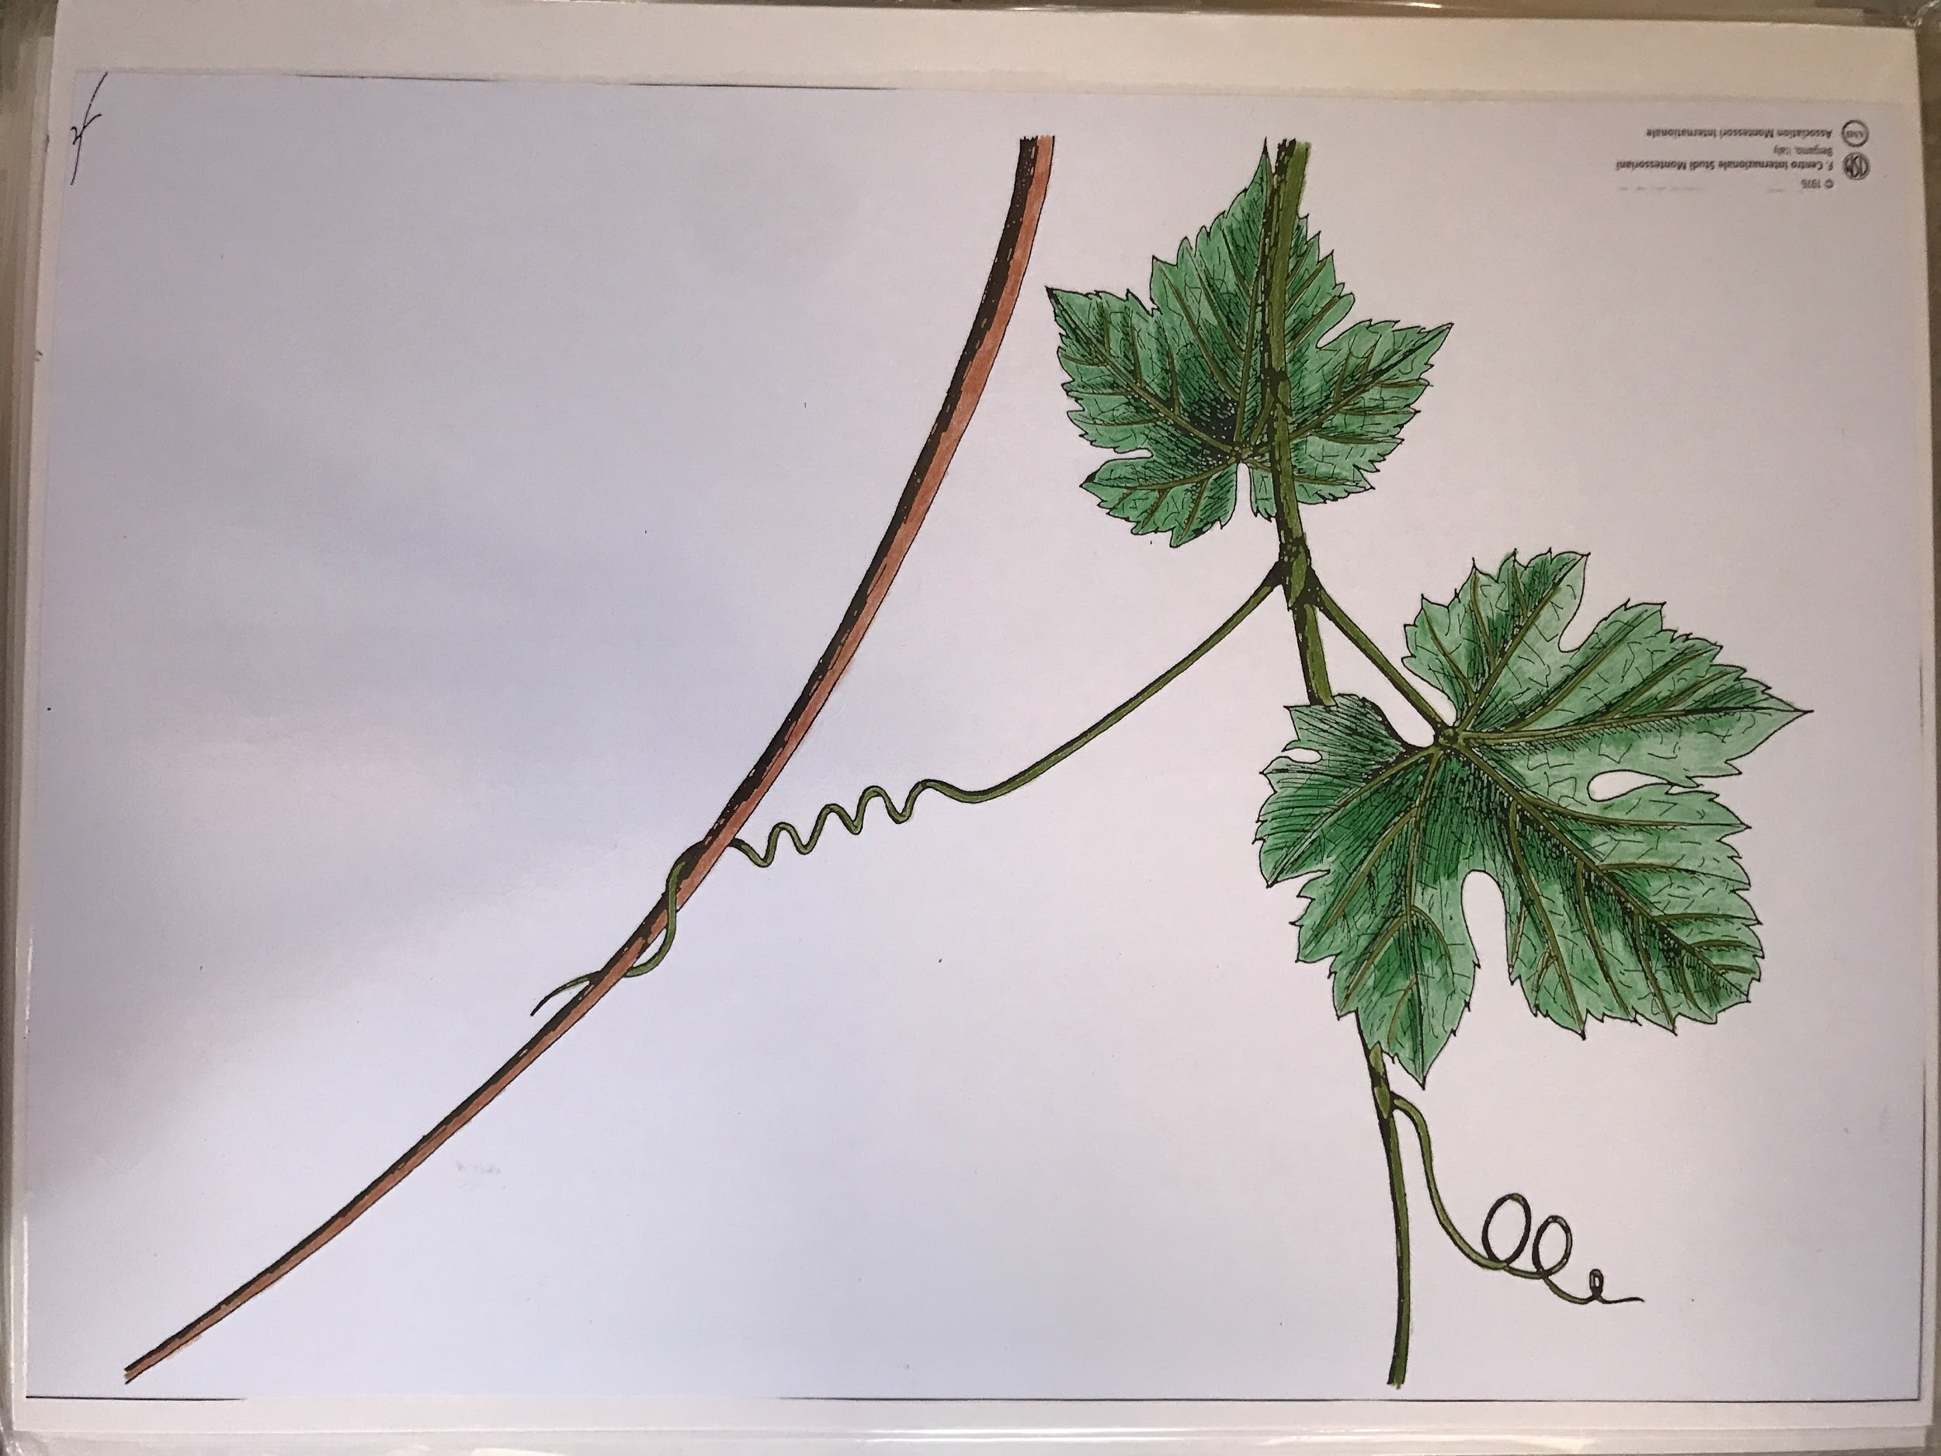

Show chart #16 - We can see that the whole plant is wrapping itself and climbing around a tree trunk, a support. This one needs some way to hold on, so we can see that it has little hooks. We see it enlarged on the right side of the chart.

There are yet other stems that are not erect, cannot stand up by themselves, but don't cling to things either. You can say that they are too proud to look for help. They just run along the ground. We call these stems procumbent stems (Latin, pro = forward and cumbent = to bend). In fact, procumbent stems are sometimes called "creeping stems". One example is the strawberry.

Notes:
- We considered subterranean stems first because they are more exceptional and more interesting for the children.
- We're not trying to tell the children everything; we want to give them enough so that they have the interest and they want to explore and find out more by themselves, on the principle that it's more about learning and less about teaching.
- We haven't talked about the internal parts and protection, which could be fascinating for the children.

Recommended books:
David Attenborough - The Private Life of Plants *(great photographs)
Collin Tudge - The Secret Life of Trees*

Standard follow-ups:
- Classified nomenclature: Parts of a Stem (purchase here)
- Exploring the outdoor environment

Notes:
- As regards erect stems, they can be woody, herbaceous, or shrubby. Green/herbaceous stems make food for the plant.
- We need a space in the home where we can bring things in on a temporary/rotating basis to satisfy the needs of the explorations taking place at any particular time; a nature table or nature shelf is great for featuring the items we’re studying.

Further exploration (left to the children):

- Dicots and Monocots (cotyledons): Purchase sorting material here

- Connections with FHN: explore the origin and uses of potato, onion, asparagus in different cultures

